***Floating Z-Axis [6.0]***

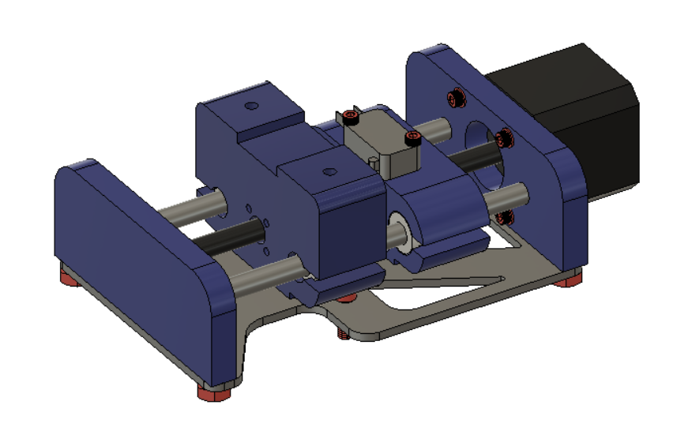

***Bearings [6.1]***

**Parts Needed**

**1x Top Slider (3D Printed)**

**1x Bottom Slider (3D Printed)**

**4x 8mm Linear Bearings**

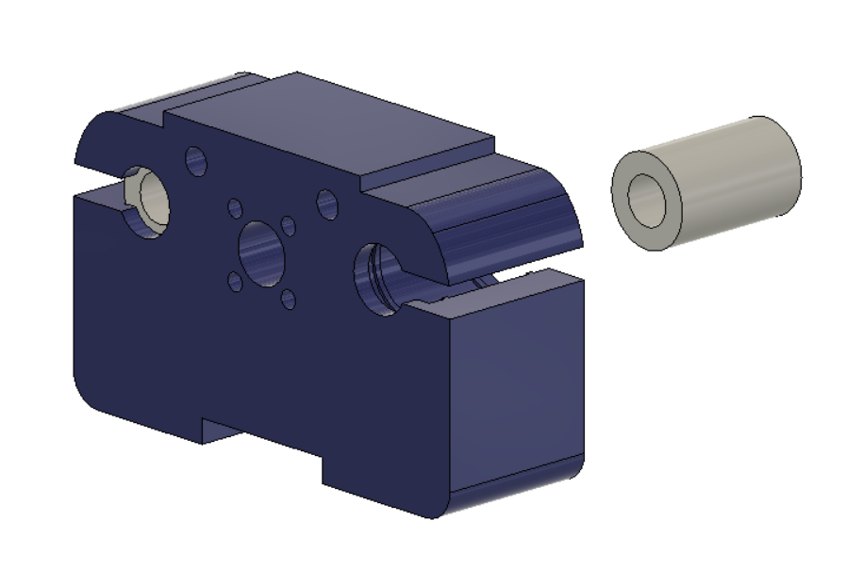

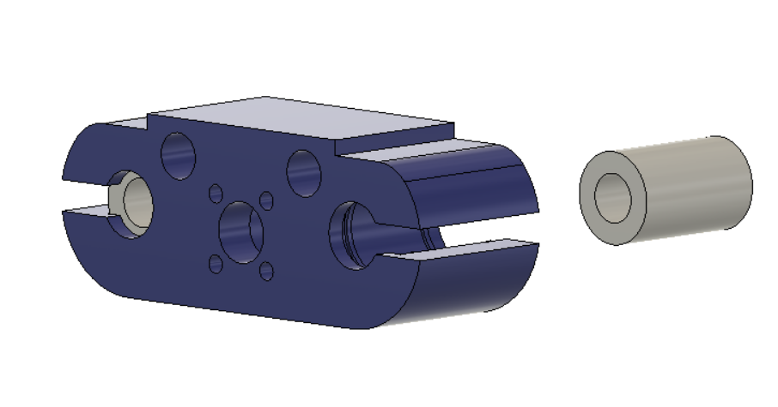

Press the linear bearings in with a vice or press of some kind. Do not hit them with a hammer. It is difficult to get the bearings pushed in square and you can damage them with a hammer. The bearings can be removed but they will not hold as well if they are pressed back in again.

***Motor Nut [6.2]***

**Parts Needed**

**1x Top Slider With Linear Bearings (3D Printed)**

**1x Brass Motor Nut**

**4x M3x12mm Socket Head Screws**

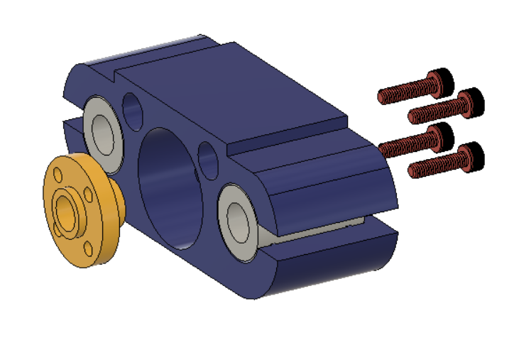

Push the nut in through the cavity on the bottom of the slider secure it with the M3 screws.

***Switch [6.3]***

**Parts Needed**

**1x Assembly 6.2**

**1x Switch**

**2x M3x20mm Socket Head Screws**

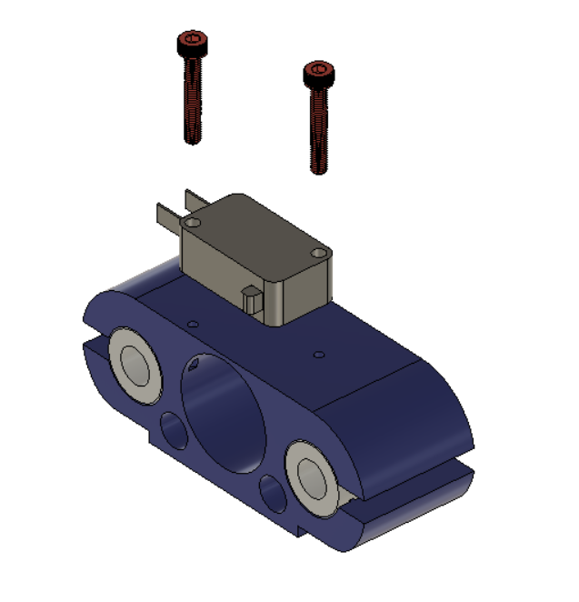

***Motor Mount [6.4]***

**Parts Needed**

**1x Top Mount**

**1x Motor**

**4x M3 Washers**

**4x M3-16mm Socket Head Bolts**

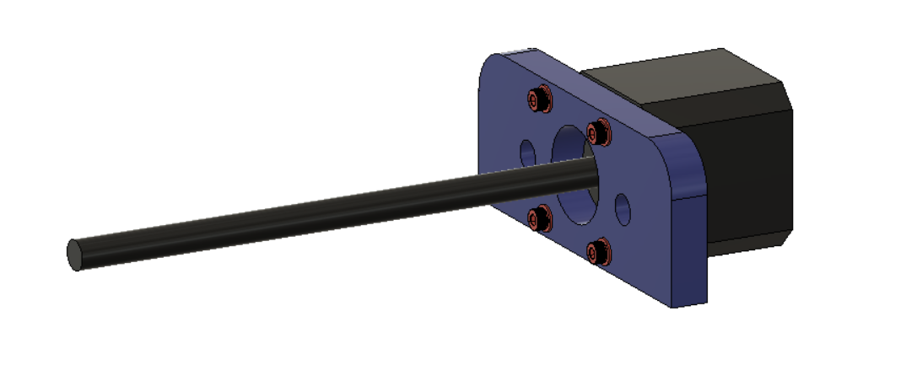

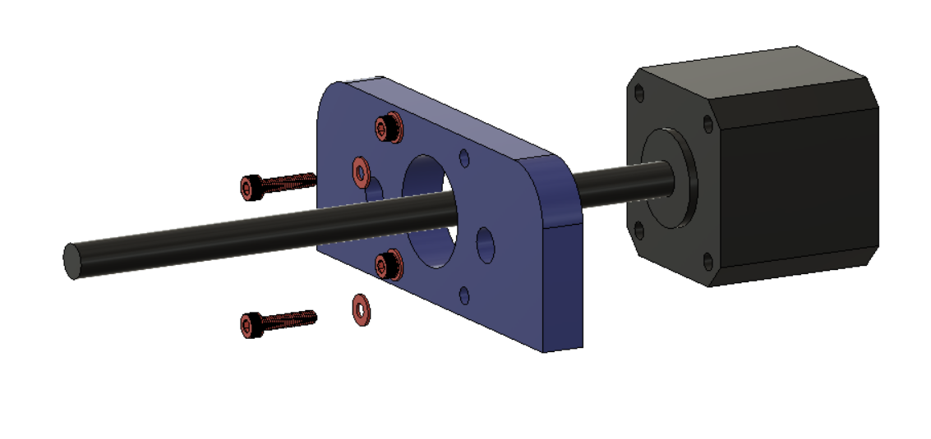

***Floating Assembly [6.5]***

**Parts Needed**

**1x Top Slider Assembly**

**1x Bottom Slider Assembly**

**2x Compression Springs**

**2x 1/4” - 2.25” Bolts**

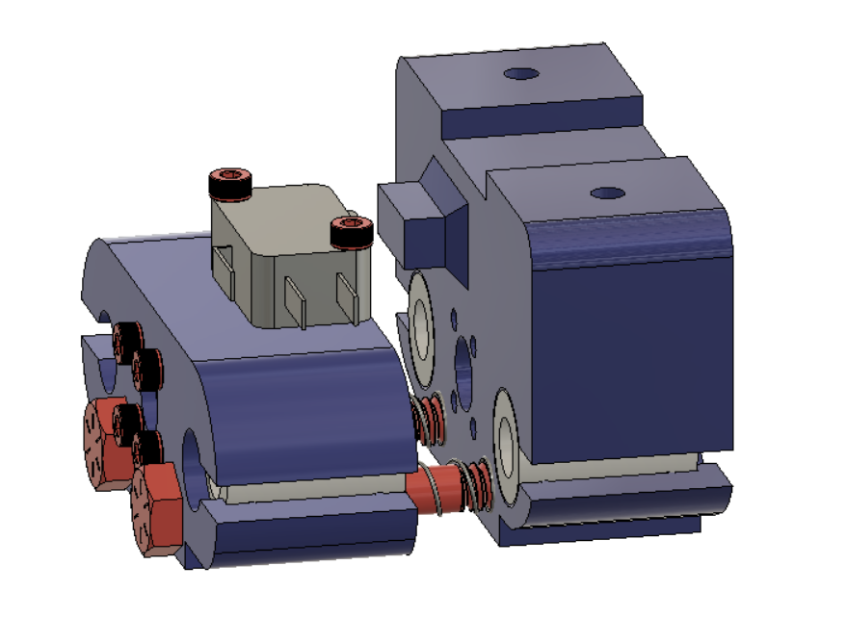

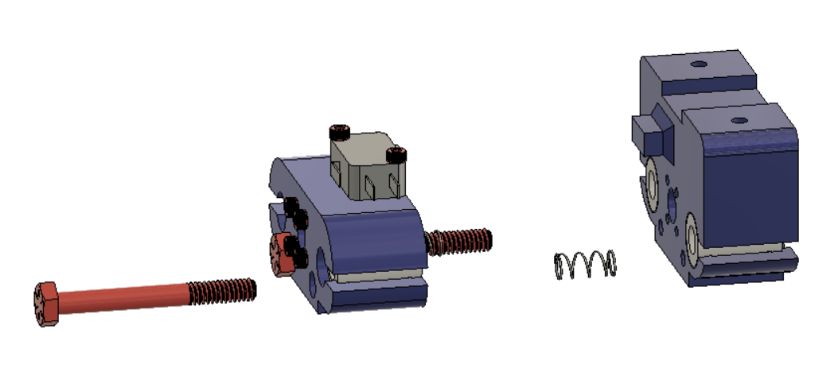

Lubricate the bolts before pushing them through the top slider. Place the compression springs on the bolts and thread the bolt into the bottom slider. Continue to tighten the bolts so that there is preload on the springs, there is no “right” amount to tighten them, you do want to be fairly close but not close enough that the switch is pressed. On our system the sliders will move 3mm before the switch is pressed. This assembly should move freely and the springs should be able to return the assembly to an extended state when not compressed.

***Bottom Mount [6.6]***

**Parts Needed**

**1x Assembly [6.4]**

**1x Assembly [6.5]**

**1x Bottom Mount**

**1x 608 Bearing**

**2x 8mm Shafts**

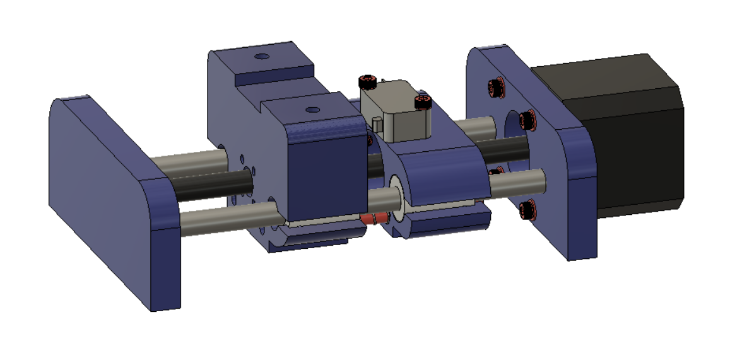

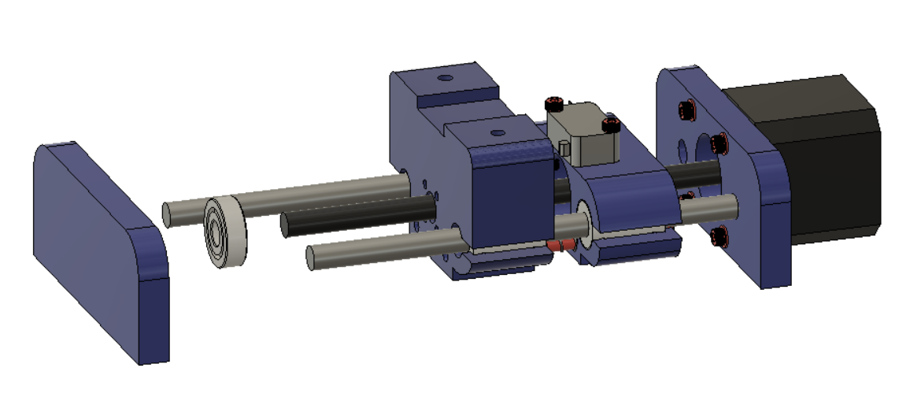

Press the 608 bearing into the bottom plate. Slide the 8mm shafts into the top plate. Next thread the sliding assembly onto the motor shaft, make sure that the shafts slide into the linear bearings when threading the assembly on. Finally push the bottom plate on.

***Mounting Plate [6.7]***

**Parts Needed**

**1x Assembly [6.6]**

**1x Mounting Plate**

**4x 1/4” Washers**

**4x 1/4” - 0.5” Bolts**

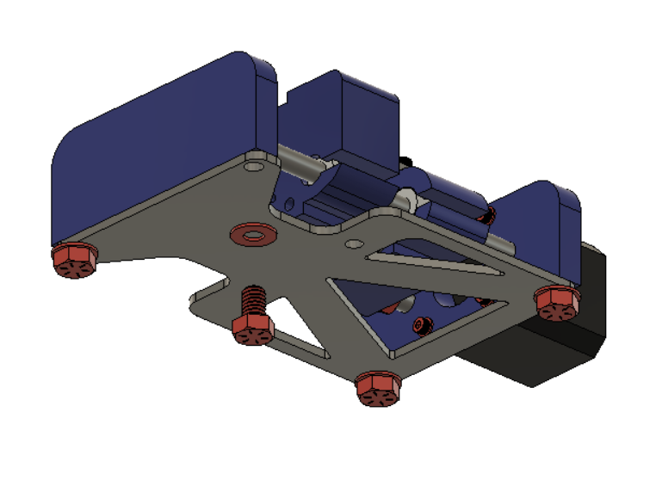

The 8mm rods should have no play once the plate is fastened. If they have play loosen the mounting plate bolts and clamp the top and bottom cap together then tighten the bolts again.

***Fitup [6.8]***

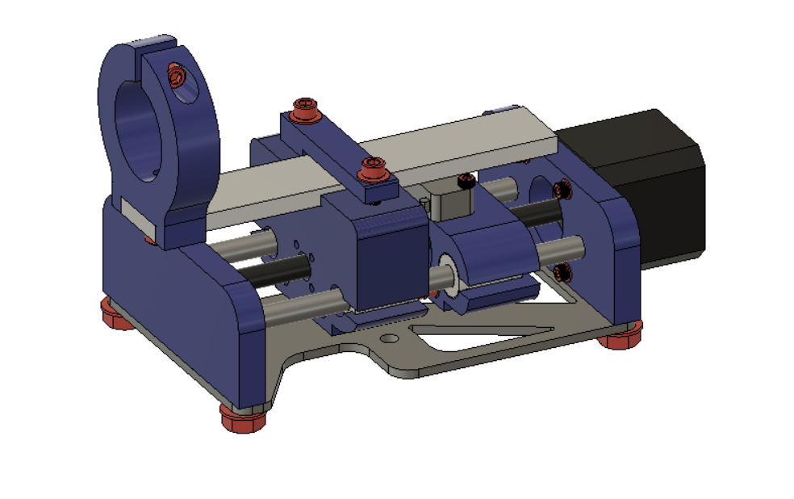

Move the torch holding assembly from the X-axis to the Z-Axis as shown. If you have not used the plasma cutter with only the 2 axes refer to step 3.3 for torch holder assembly.

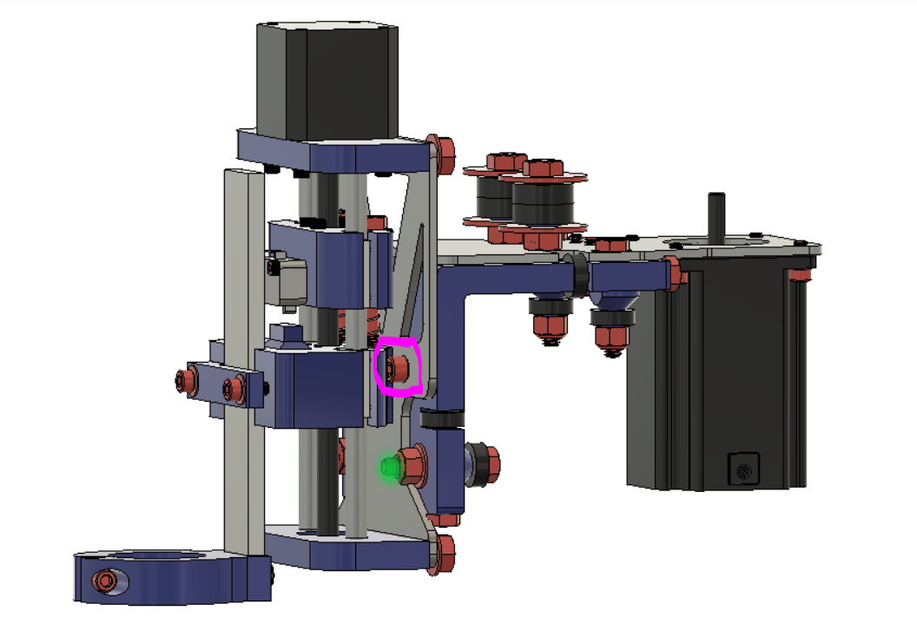

Use two 1/4” - 0.625” Socket Head cap Screws to secure the Z-Axis to the X-Axis using the same holes that were once used for mounting the torch.

If you have not already cut off the bolts highlighted in green you will need to cut the excess off so that it sits flush with the end of the nut. This excess will cause clearance issues.

With the addition of the Z-Axis it will now provide a 2” offset in the negative Y direction to the torch. To regain the same cutting area you need to make the **51" Lower Y-Frame Rail Z axis Addition Tube.** The drawing for the tube is in the drawings folder. If you have already been using the machine and would like to add the Z-Axis you will need to move the 4 holes in the middle 2” in the negative Y direction from where they are now. Refer to the picture below or the drawings. 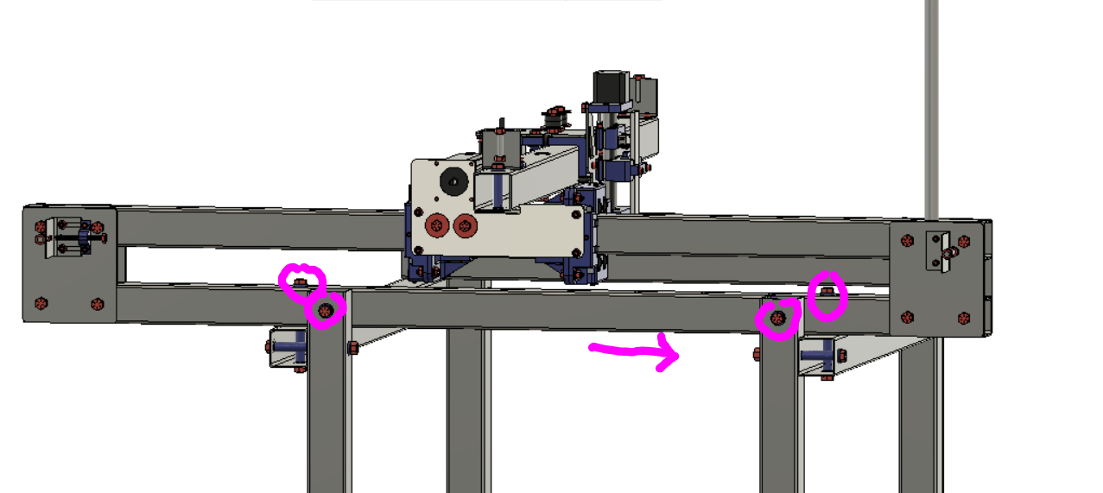

Only changes to the Lower Y Axis tube need to be made.